Gene(gene_symbol, gene_name, chromosome, chr_start_pos, chr_end_pos, strand)
Protein(accession_number, chain_length, molecular_mass, function, #gene_symbol)
Domain(domain_name, family, domain_description)
Contains(#accession_number, #domain_name)
Chaque gène se situe sur un interval sur le chromosome qui commence à partir d’une position et qui finit dans une position de fin.

Extraction des données : enembl BioMart
Filtres appliqués :
Dataset Human genes (GRCh38.p14)
Phenotype source : Cancer Gene Census
The Cancer Gene Census is a high-confidence list of genes with substantial published evidence in oncology.
Attributes
Gene stable ID
Gene stable ID version
Transcript stable ID
Transcript stable ID version
Gene description
Chromosome/scaffold name
Gene start (bp)
Gene end (bp)
Strand
Gene name
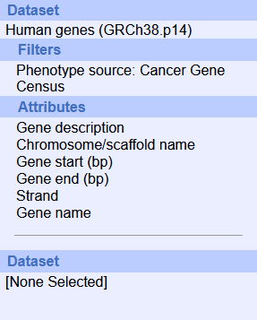
UniProtKB
